Install Playwright:
We can find playwright documentation in: https://playwright.dev/docs/intro
We will install playwright using the command :
npminitplaywright@latest.
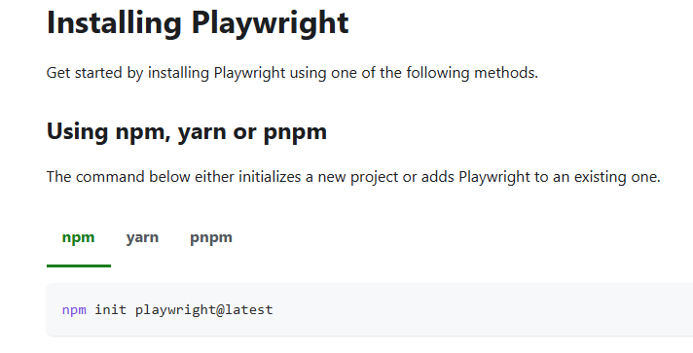
- We will select language as typescript.
- We will put E2E tests under test folder
- Install playwright browsers
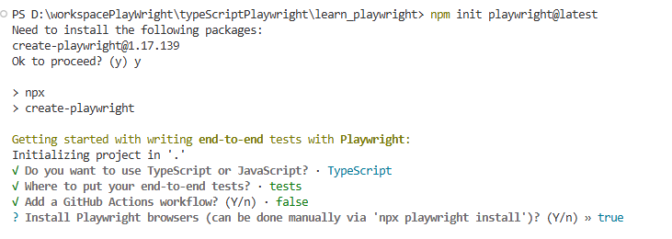
- Under node_modules we can see all the dependencies
- Under tests folder we can see the sample tests
- Under gitignore files we will find the folder which we will not include while pushing cod to git.
- Under package.json we will mention all the dependencies.
- Under playwright config we can add some properties.
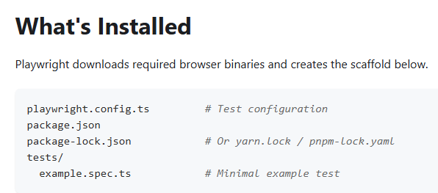
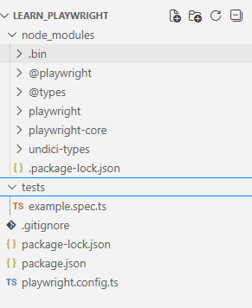
To execute the sample playwright script we use the command: npx playwright test
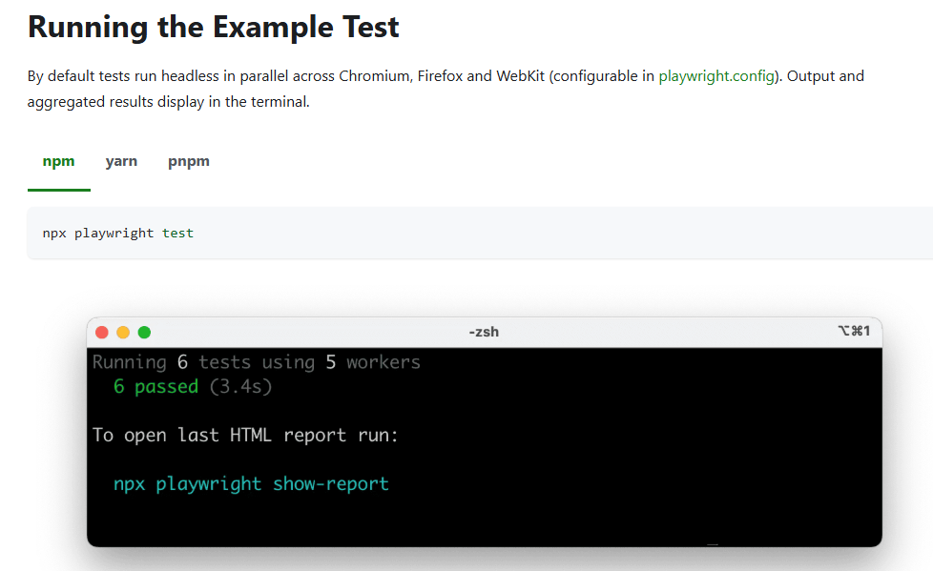
We see that 6 test is executed using 2 workers. This means that script got executed in parallel mode using 2 threads.
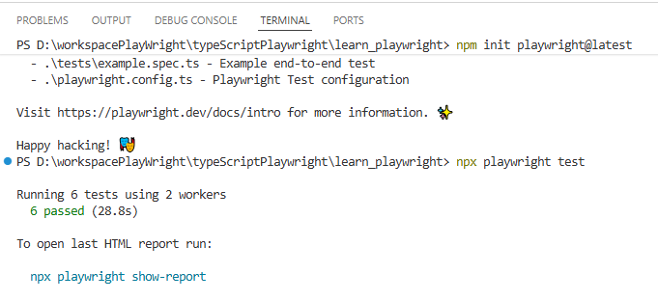
We can see the report using the command: npx playwright show-report
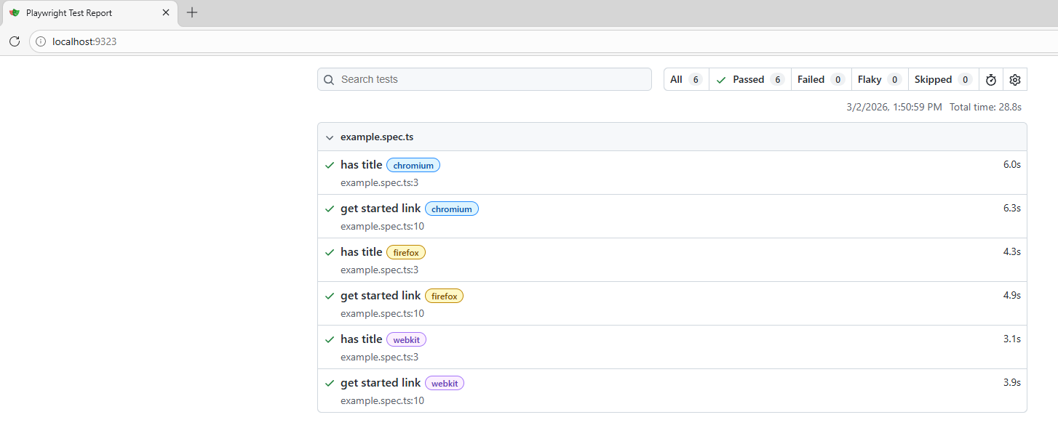
We can also install and extension called playwright test.

Once installation is done click on View -> Command Pallets
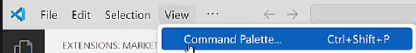
Select Test install playwright.
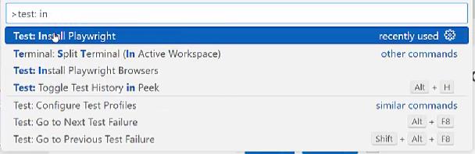
Select only chromium and firefox.
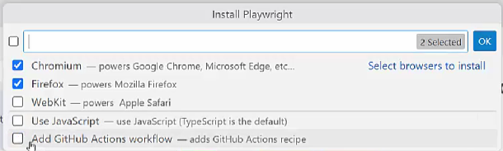
The benefit of this plugin is that we can see Run button beside each test.
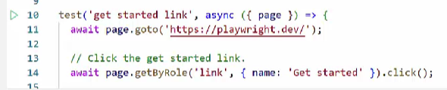
As of now script is getting executed in headless mode. To execute in real browser we add the following code in the configuration file.
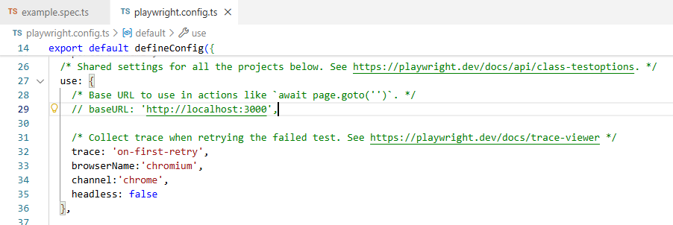

Write First test case:
We import test and expect from the playwright test packet which is the testing library of playwright.
“Test” is used to write the test cases and “Expect” is used for assertions. If we remove test or expect we will start getting errors in our test.
Test is a function used to define individual test case. First parameter is the test name which describes the test. Async makes the function asynchronous. All playwright operations are asynchronous such as interaction with the page, waiting for an element, clicking an element, navigating to a page. Whenever we use an asynchronous function we will use the async keyword.
Page is an instance of playwright page class. We use it to interact with browser page by calling method as navigating, clicking, typing etc. Await keyword is used to ensure before each user interaction. %this ensures that first operation is completed before the next operation is triggered. Since playwright function returns promises we need to handle with async and await. We can also do the same operation using “then” if we don’t want to use await and async.
Page.title() -> returns the title of the web page.
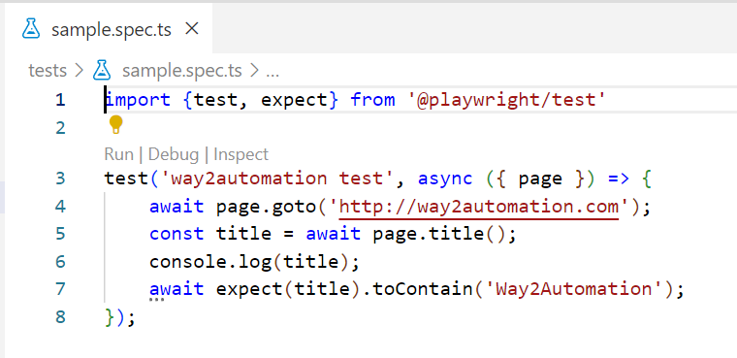

Browser Navigation Methods and Finding elements:
For learning purpose we will add some delay to the application so that we are able to see the execution.
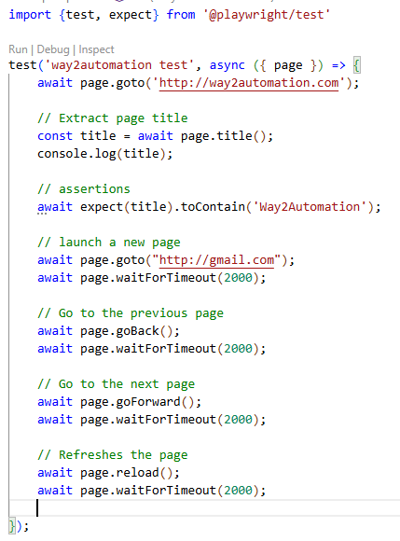
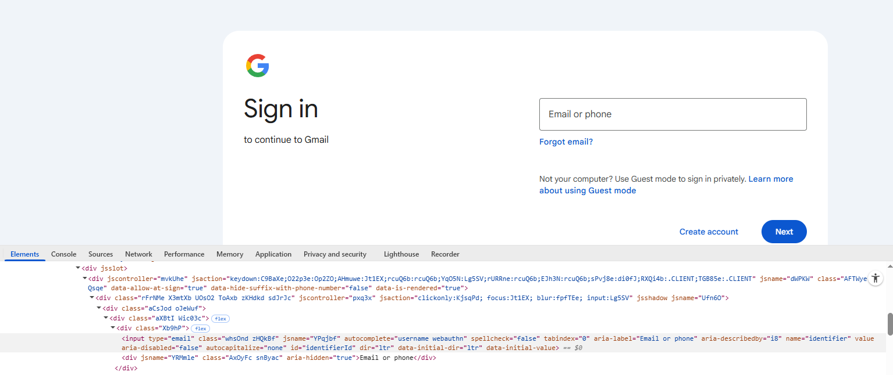
We open Gmail login screen and we see that login textbox has a property called “aria-label”.
Instead of identifying the element using “page.locator” we can use “page.getByLabel”.
Using “fill” we will enter text in the textbox.
One thing to note her is that there can be other element with the label as “Email Or Phone”. We can add some additional property in the form of regular expression. If we want exact match of the label we can use the property exact and set it to true.
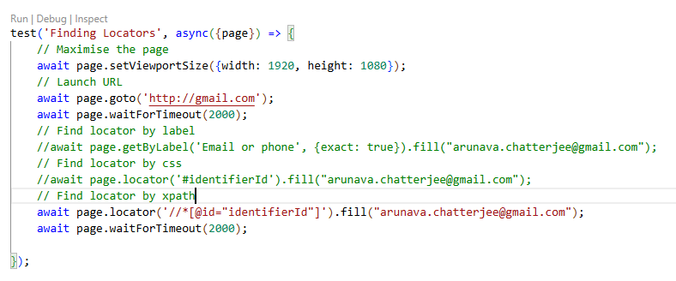
Next we would like to click on the next button.
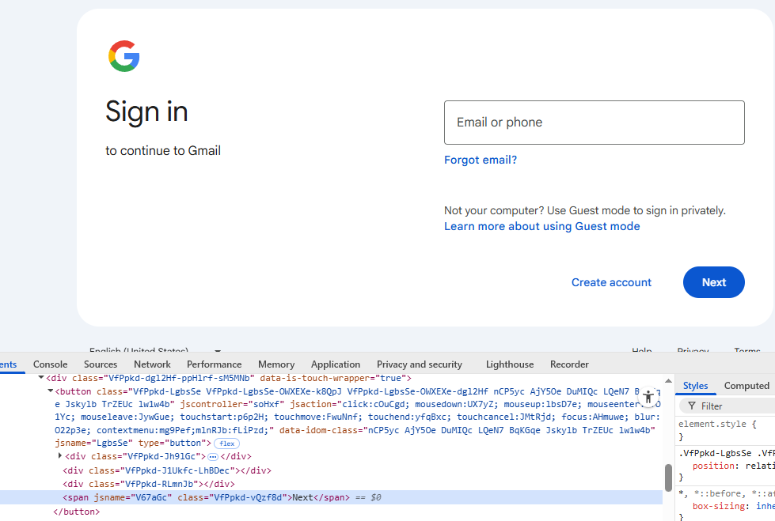
We see that next button is enclosed in button tag. We can put regular expression to filterby text.
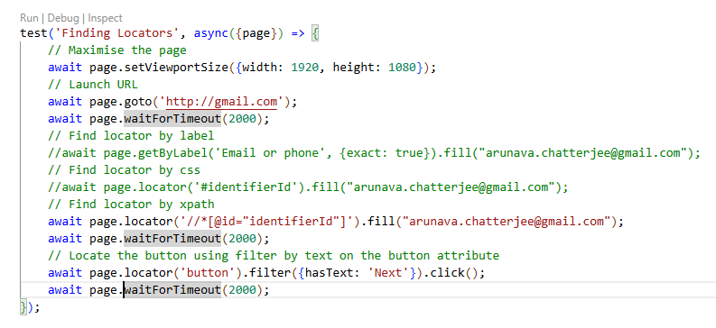
In case of Selenium when we needed to wait for an element using explicit wait but is handled internally in playwright.
Handling dropdown box:
Let us first see how to handle a dropdown box.
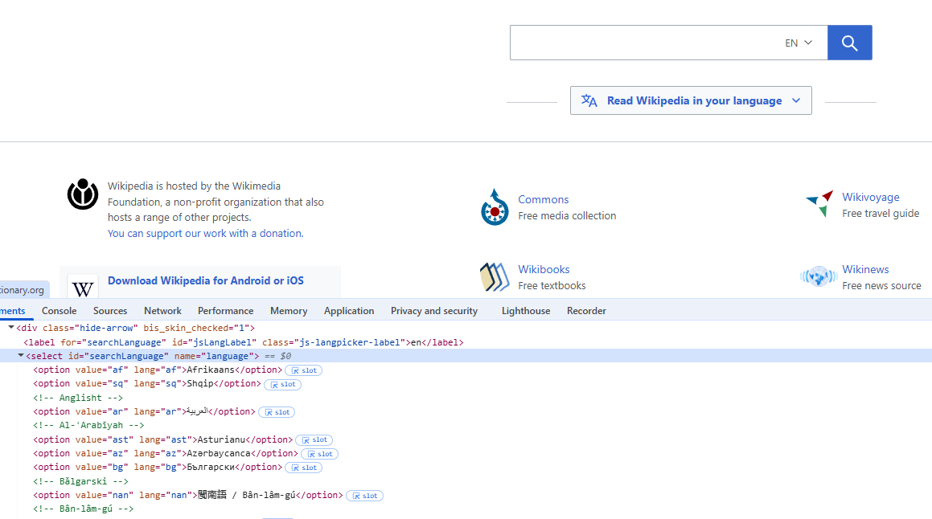
We can select element from dropdown box using 3 ways:
- Label
- Value
- Index
Within the select tag all the options are in the option tag. We can select all the options by applying all functions on the option tag.
Using innerText function we extract the text of the element and using getAttribute we fetch value corresponding to an attribute.
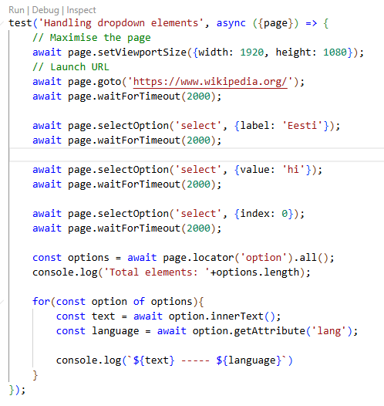
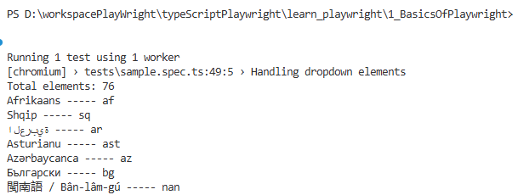

Handlinglinks:
All the links are in the anchor (a) tag.
Using nth we can identify a single element from the list by passing the index.
In the footerNavBlock we have identified the footer elements. We can narrow down the search by passing indexes.
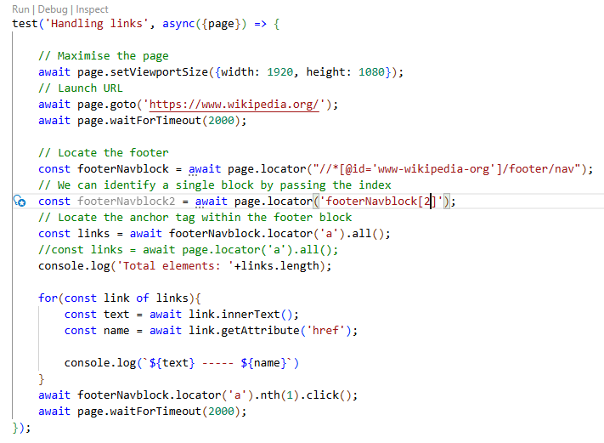

Handling Checkboxes:
Count function is used to count number of web elements.
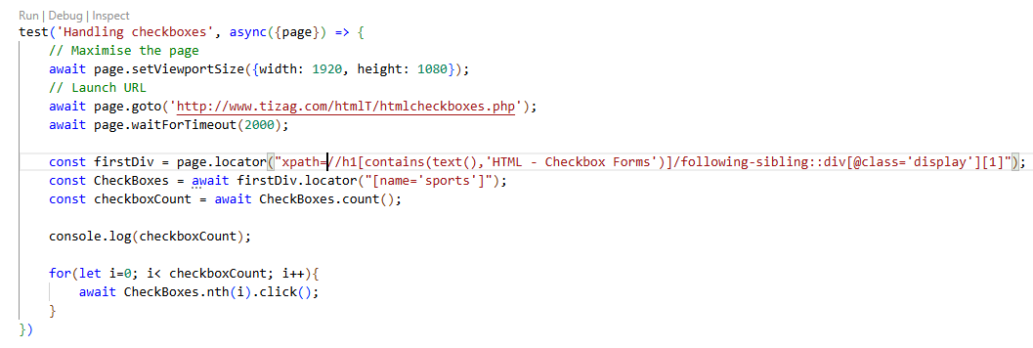
Assertions:
- toHaveURL -> verify the URL of the page
- not.toHaveURL -> verify whether the URL does not contain a particular text like error.
- toHaveTitle -> Verify title of a web page
- toHaveText -> Verify whether element has a particular text
- toBeVisible -> Verify whether element is visible
- toBeChecked -> Verify whether checkbox or radio button is checked.
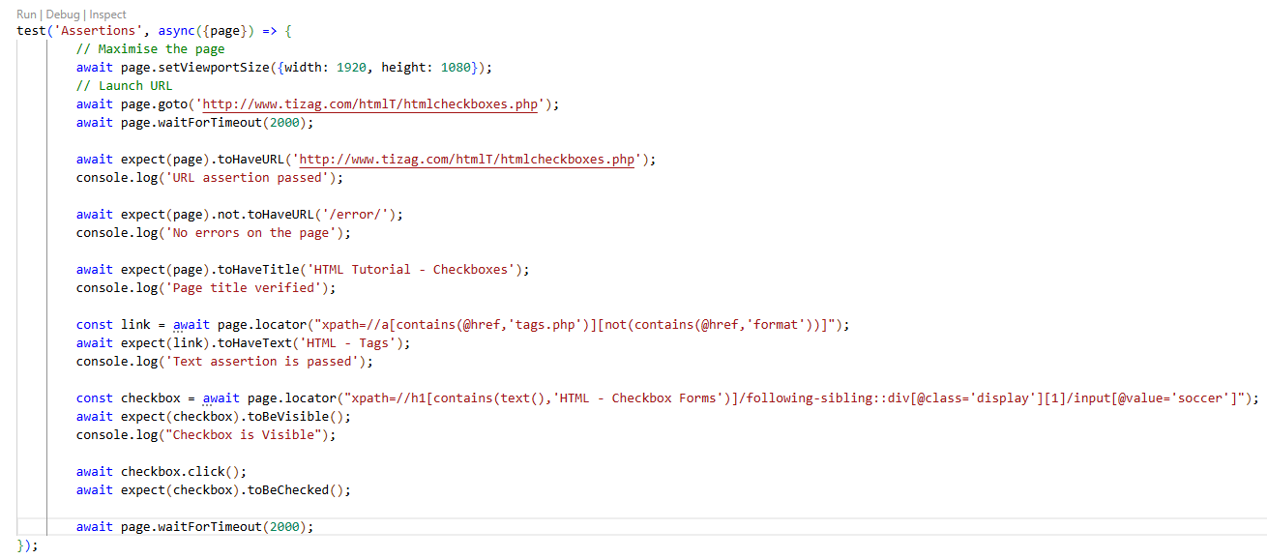
Handling web tables:
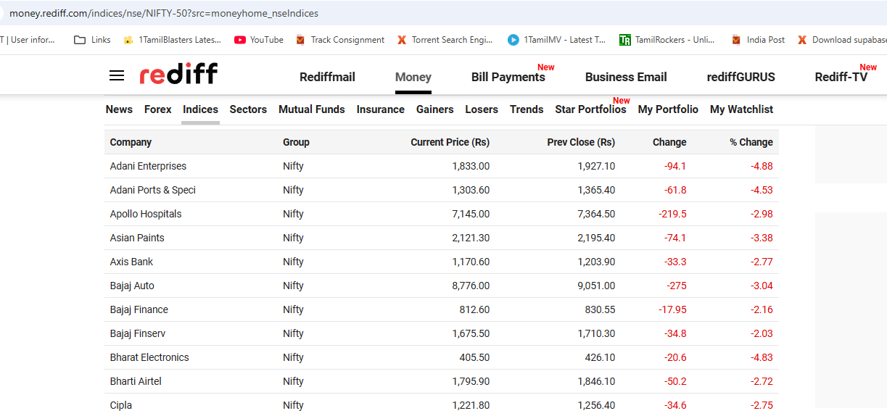
Here we will see how to handle web tables. We have taken the count of number of rows and number of columns. Then we have extracted the value of the cell corresponding to the first row and first column and verified whether the name is “Adani”. “allInnerText” function fetches all the text of the list of web elements and then we will loop around it and print the values of the table in the console.
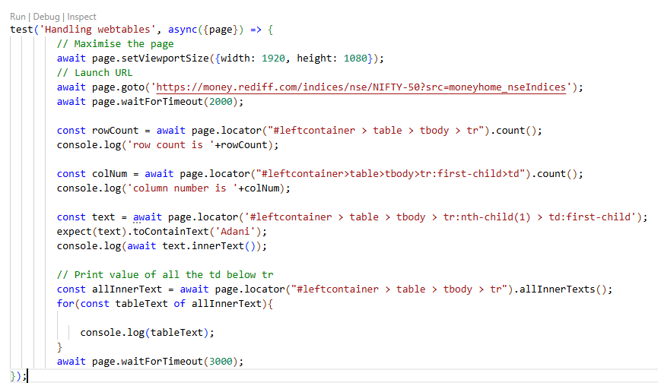

Handle shadow root element:
Handlind shadow root element is a complex task using selenium by framing the xpath but is easier to handle the same using playwright.
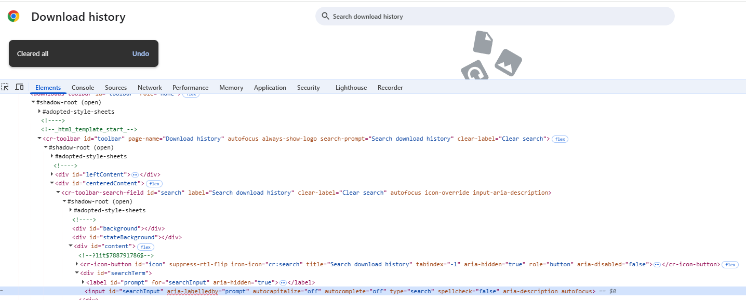
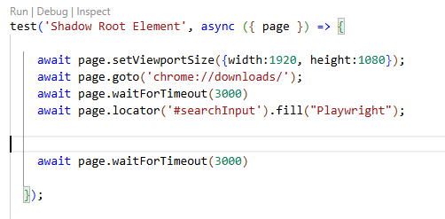

Mouse Hover element:
We will hover on All Courses and will click on the first element.
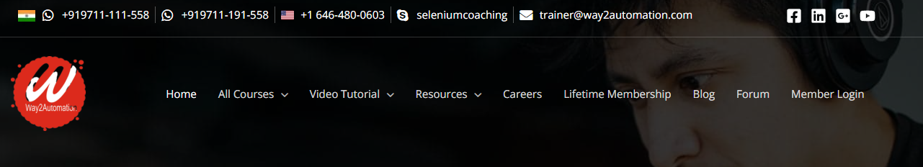
Hover function helps us to hover on menu items.
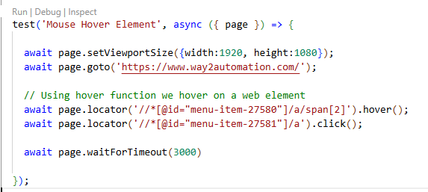
Right click:
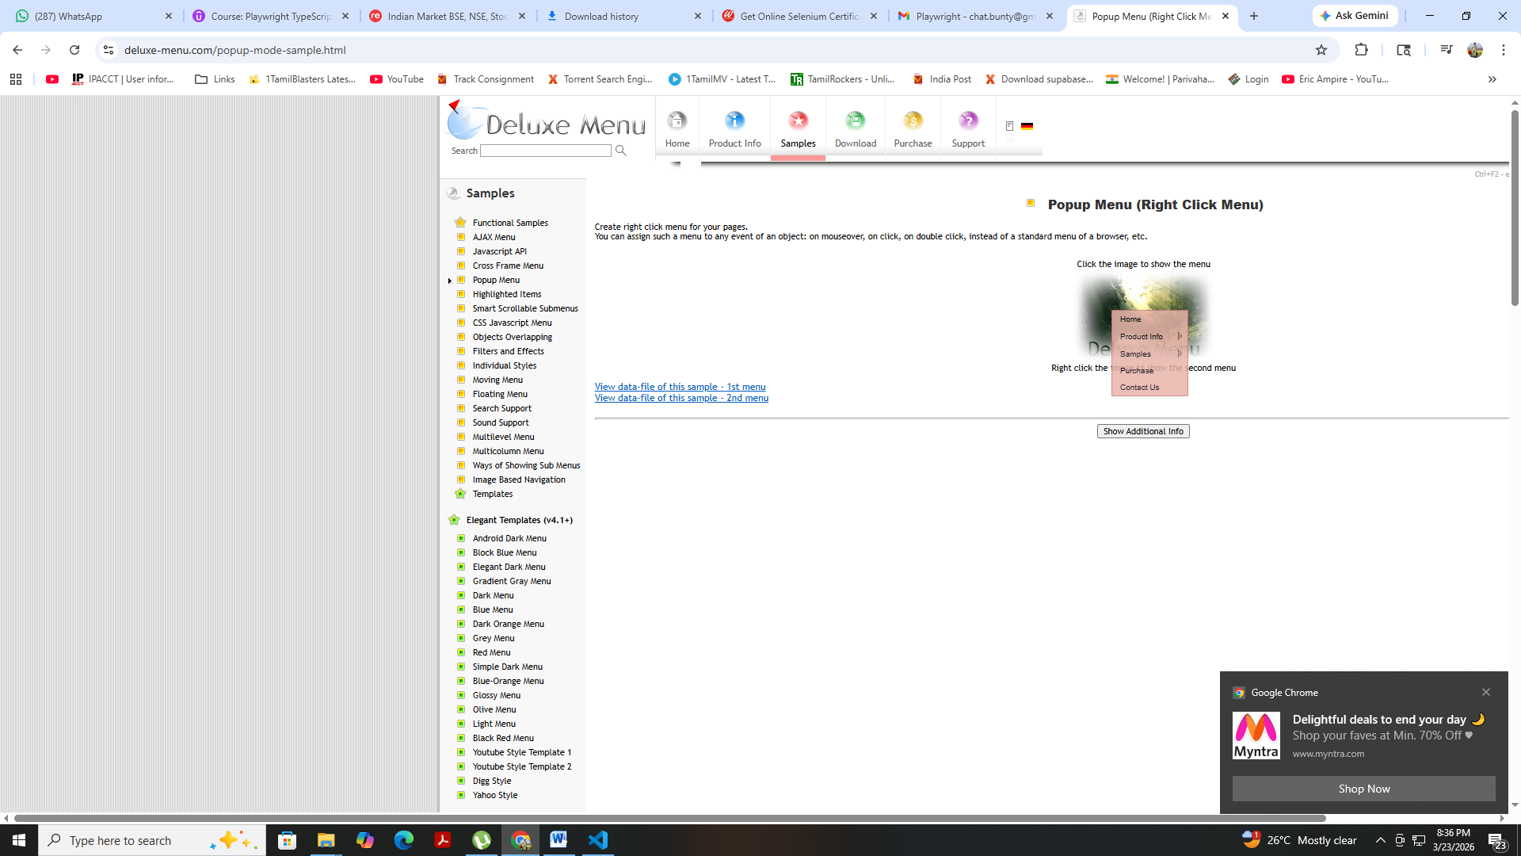
For right click operation within the click function we will pass parameter as button: ‘right’.
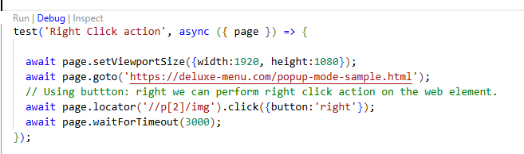
Handling Alerts:
We can go to rediff mail and click on Sign in button and we can see the alert popup. When we click on sign in button then an event is being triggered. “Page.on” is going to listen to the event. Here event is a dialog. Finally we accept the alert. Using dialog.message we print the message displayed in the alert.
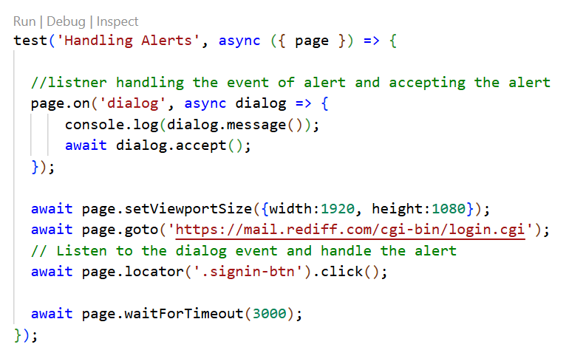
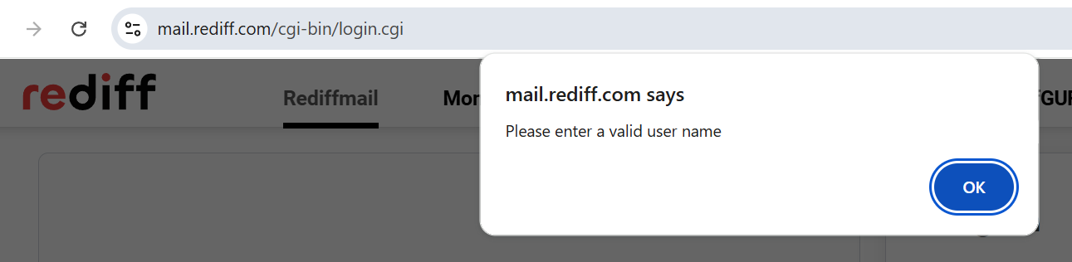
Handle Frames:
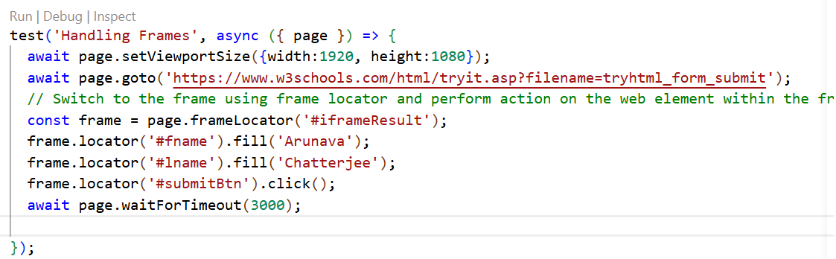
Here we see that the HTML form is embedded in a frame. First we need to identify the frame and navigate to it using the “frameLocator” and then we will perform operation within it.
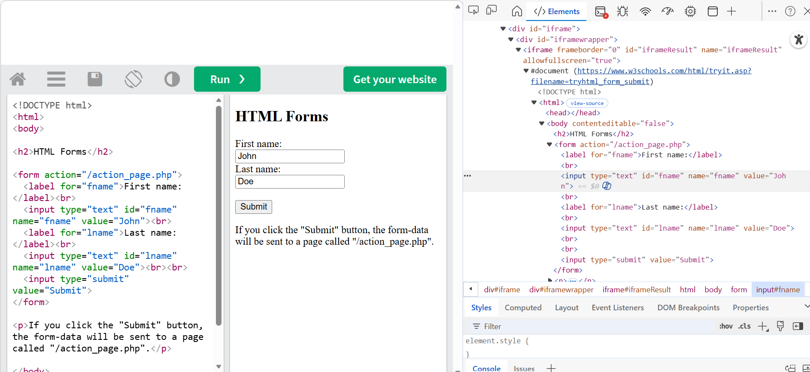

Handling tabs and popups:
To handle new page we will use promise which will contain an array of functions. First is the event that will be triggered which is a popup. And the second is the click operation which triggered that event or the popup. WaitForLoadState will wait for that popup to load fully.
Here also we have selected the first frame by passing the index.
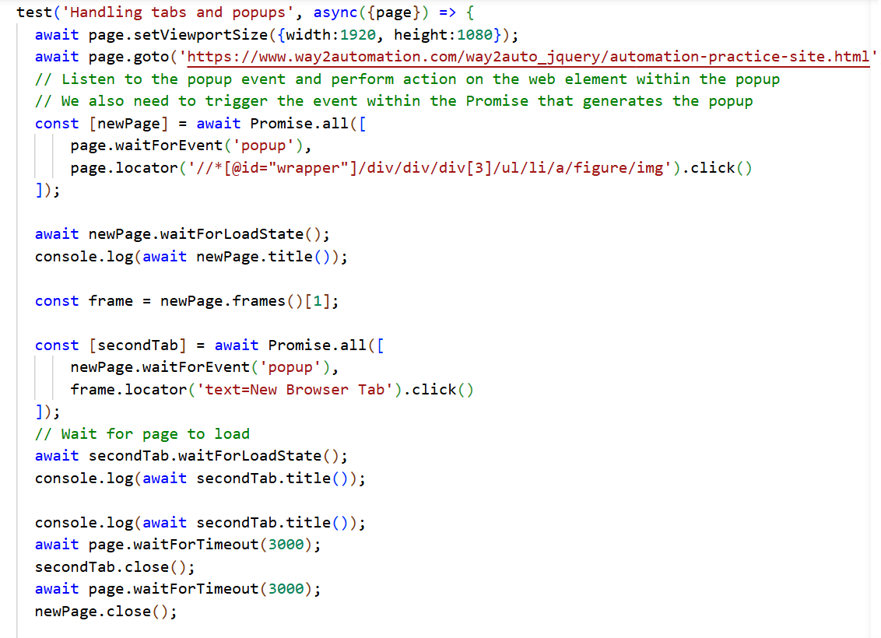

Executing Javascript:
We can use JavaScript in our automation script by using the “evaluate” function.
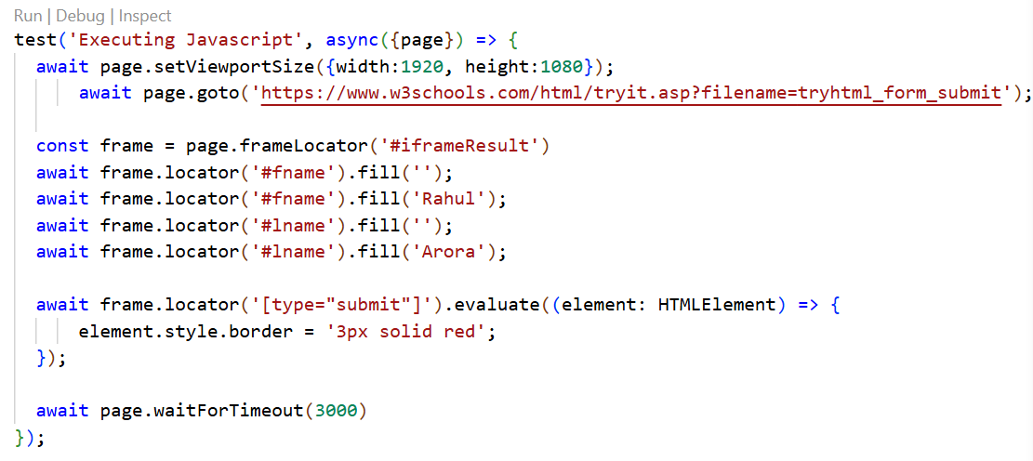
In the example we have styled the border of the submit button with solid red color.
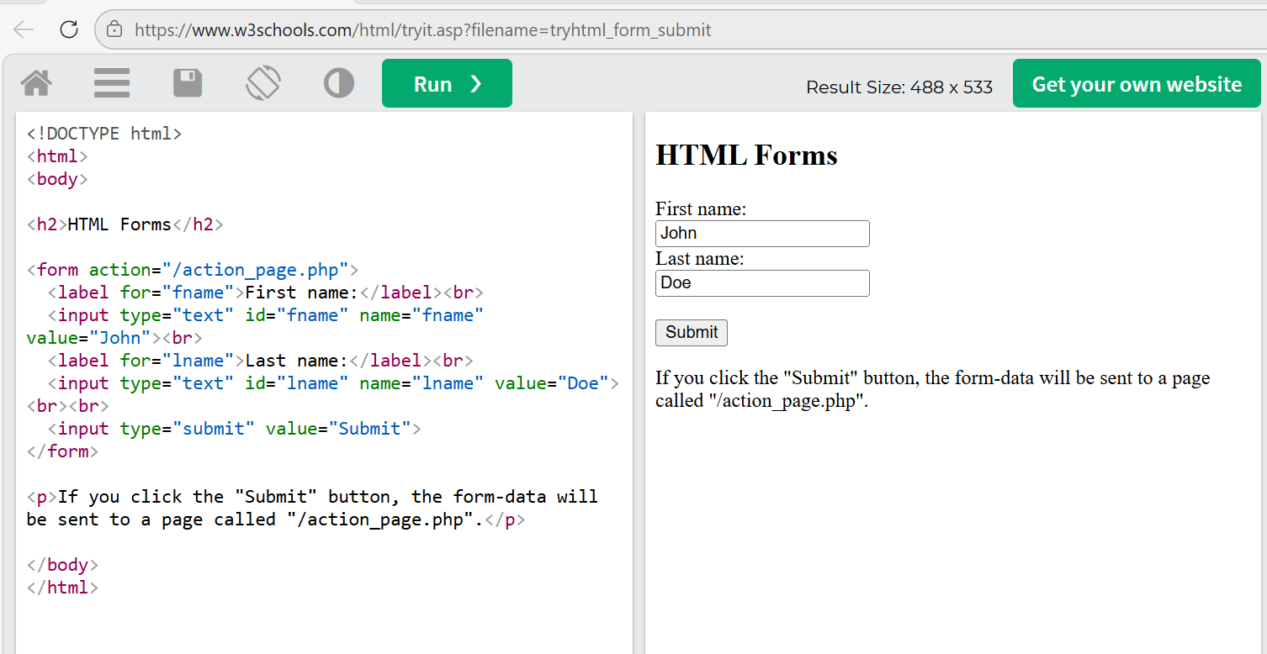

Screenshot:
We have option to take both screenshot of the element as well as screenshot of the entire page. We can take screenshot by calling the screenshot function and we need to pass the location as a parameter.
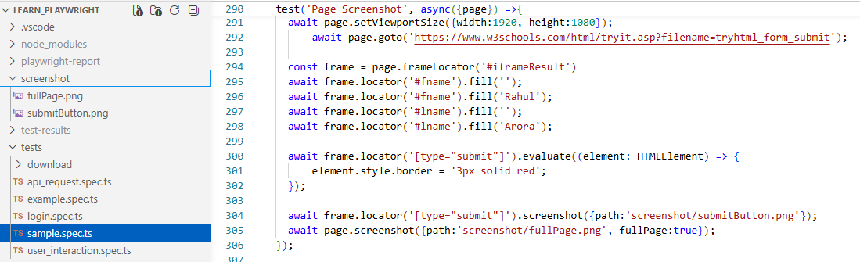
HTTP authentication:
Now we will see how we need to handle HTTP authentication request. Here instead of page object we will use the browser object. We will get the page from the browser object. We need create a browser context object with the http credentials and will use the same to create a new page.
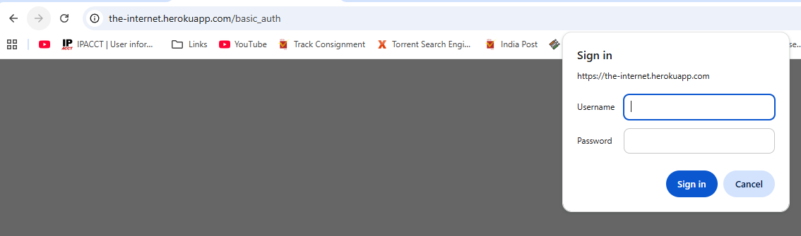
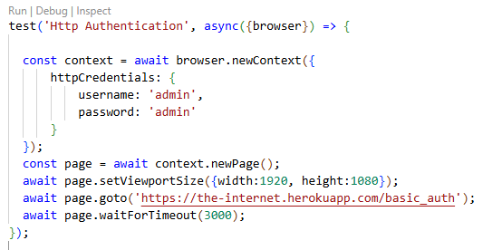
Upload file/ files:
We can upload file in an application using “setInputFiles” function where we will provide the file path as a parameter. If the file path does not exist we will create the file path.
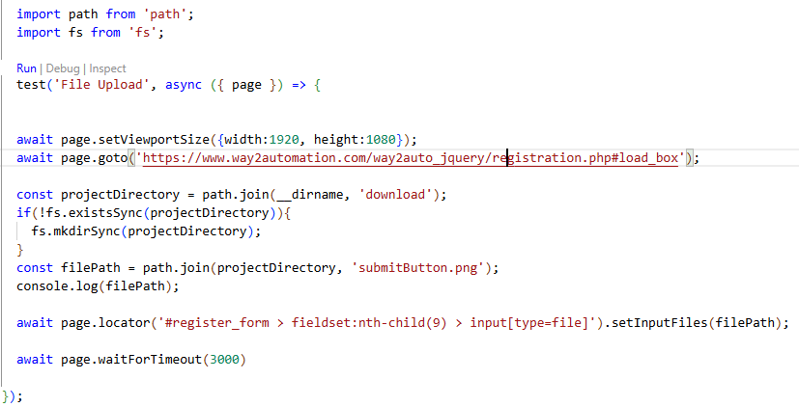
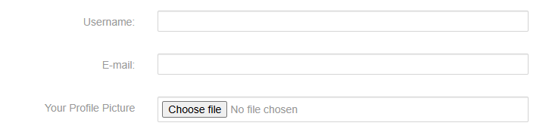
Same way we can upload multiple files. In this case we need to provide multiple file paths in the function – “setInputFiles”.
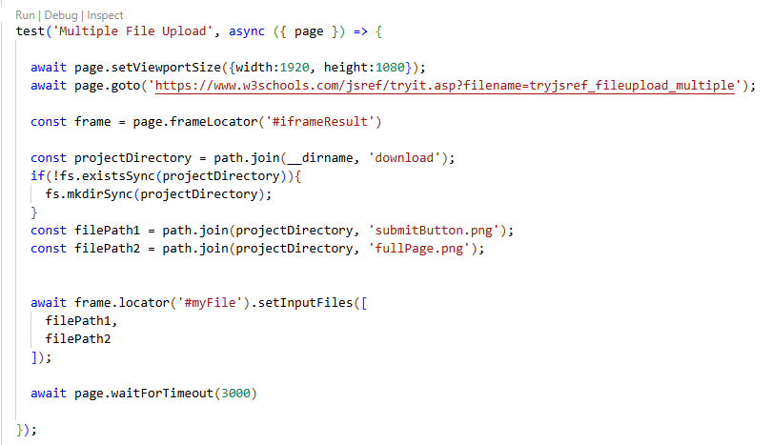

File downloading:
Here we will create a download listener which will be get triggered when we try to download a file from the internet. We will also write the code inside the block which will trigger the download event. Within the “saveas” function we will provide the file path which will help to store the file in the specified location.
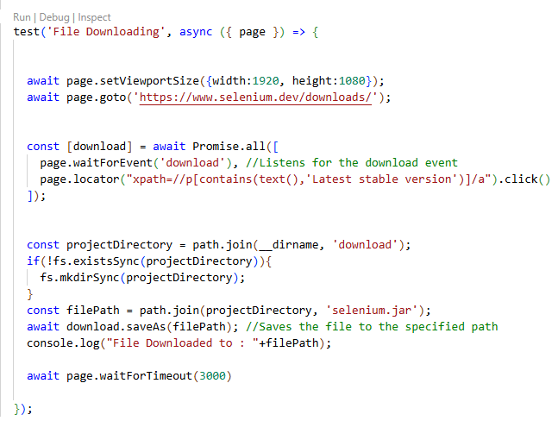

Video recording:
In playright config json file we need to set video to on state to record the video. We see report is stored under: D:\workspacePlayWright\typeScriptPlaywright\learn_playwright\playwright-report\data
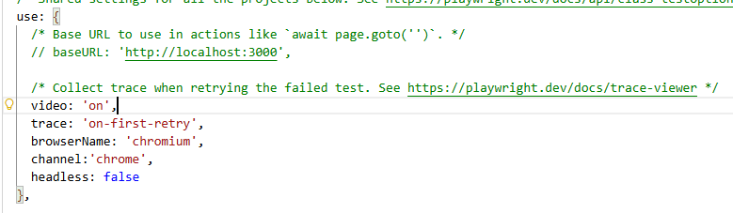
Trace Viewer:
We see a trace.zip file is created if we keep trace as on in config json file:
npx playwright show-trace ./test-results/sample-Http-Authentication-chromium/trace.zip
Using this, whatever we have executed step by step it will capture everything. It will help us to debug the code. Also we need to make sure trace is turned on.
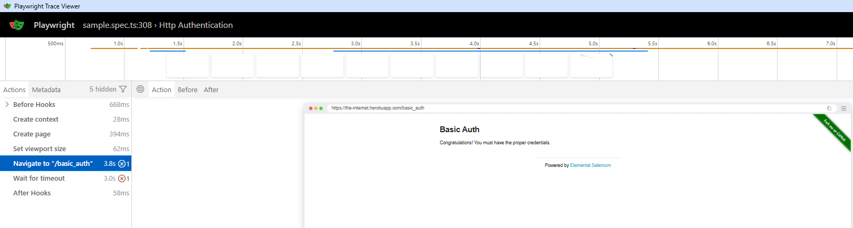
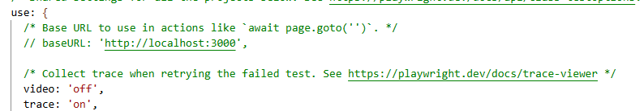
Playwright code generator [Record and playback]:
Click on the Testing lab and click on record new button.
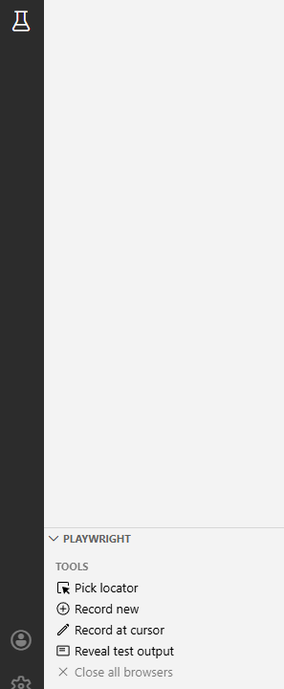
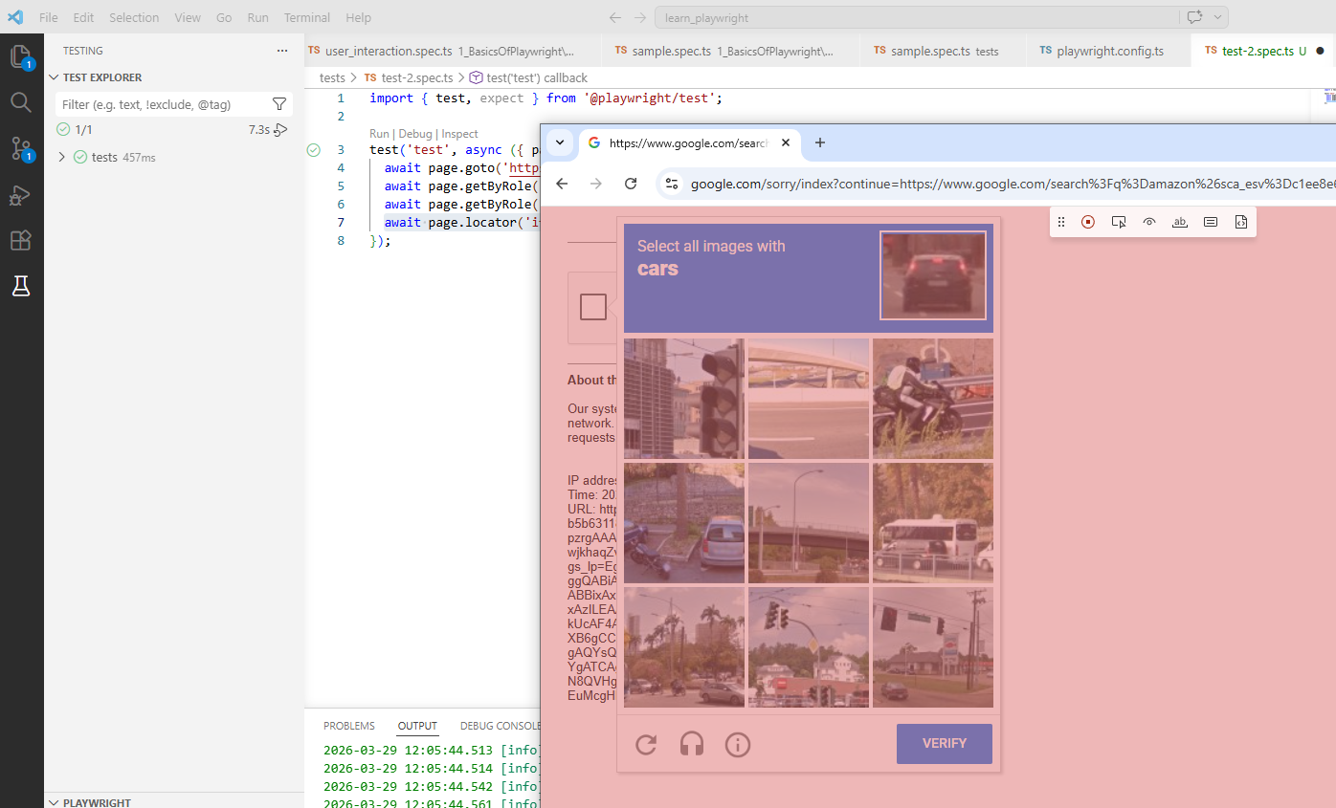

Playwright inspector:
We can pause the execution using the statement “await page.pause()”.
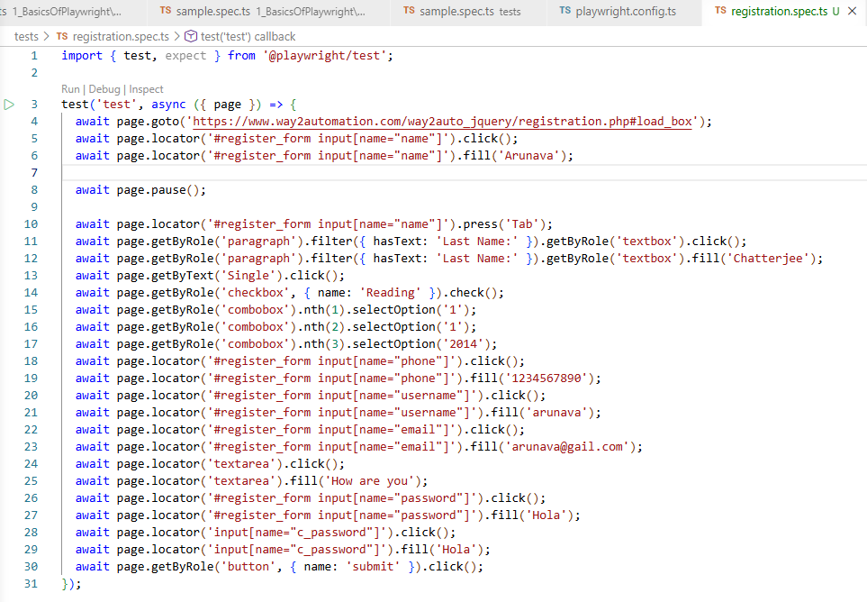
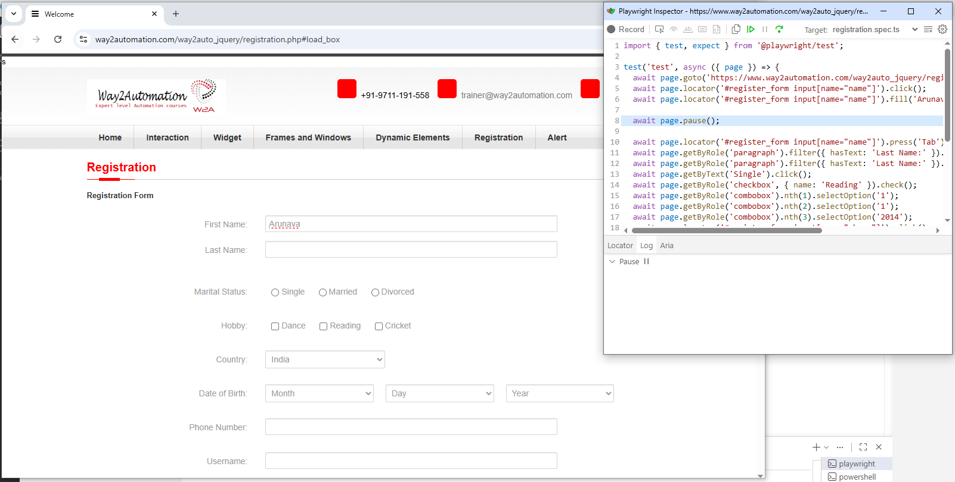

GET and POST request:
Using the following command we can trigger the spring boot service.
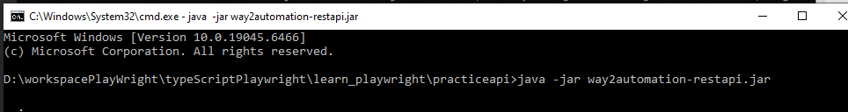
We can trigger swagger UI by invoking the URL:
http://localhost:8080/swagger-ui.html#/user-controller
